LAB – 6

# Name : Chaitanya sai

# RollNo : 22CS3026

1.

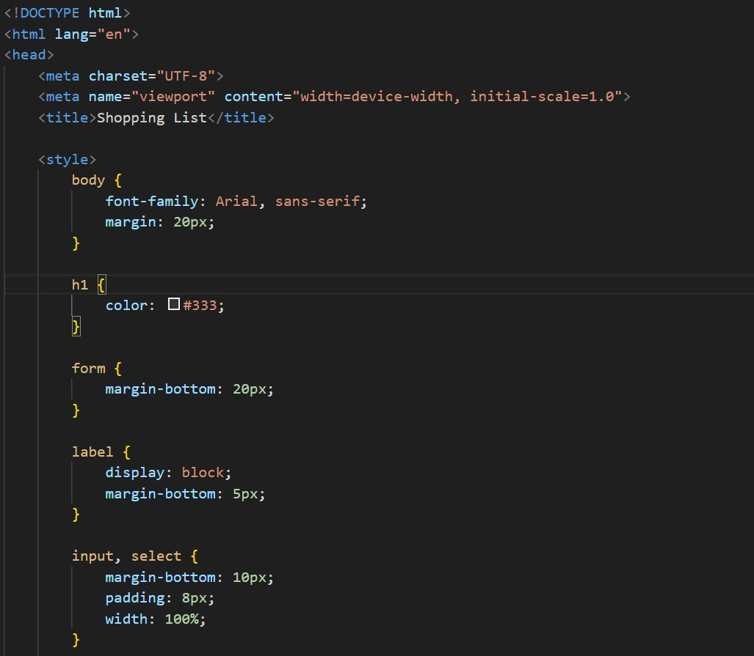

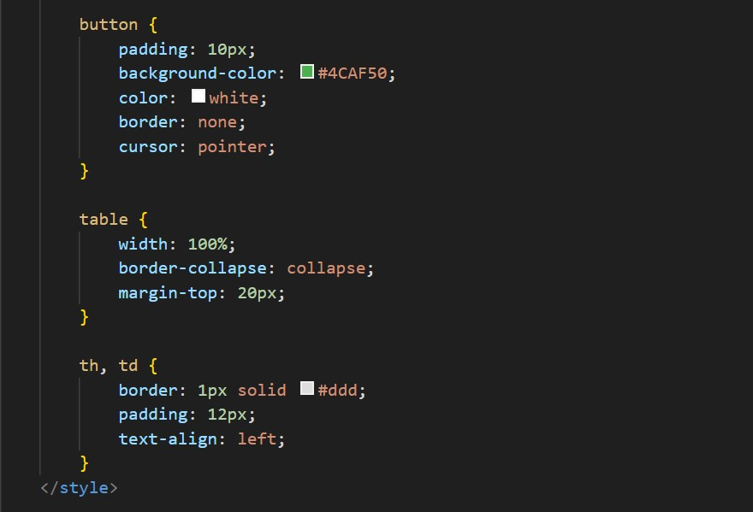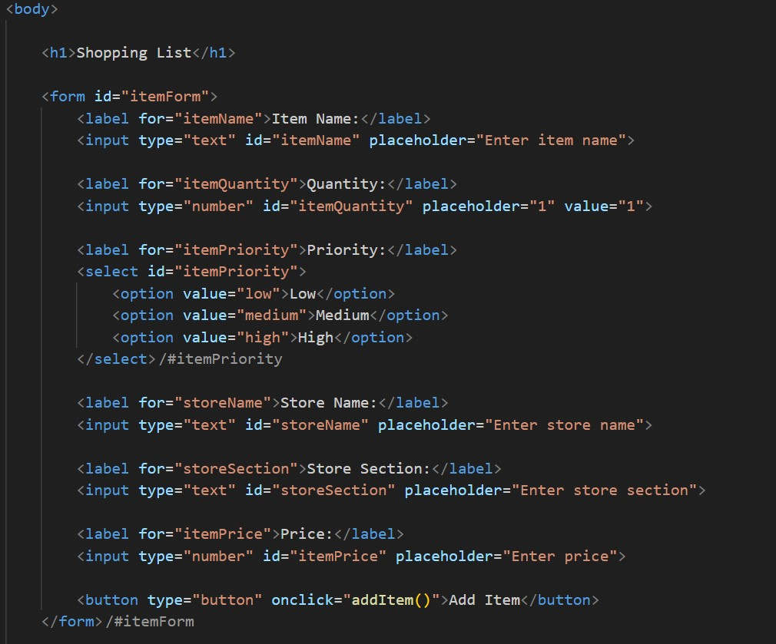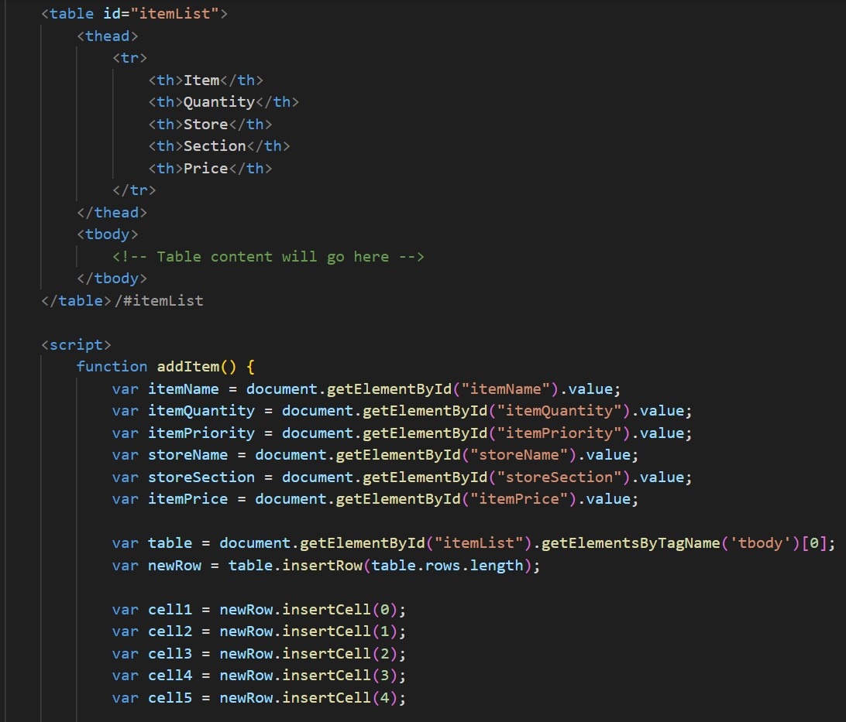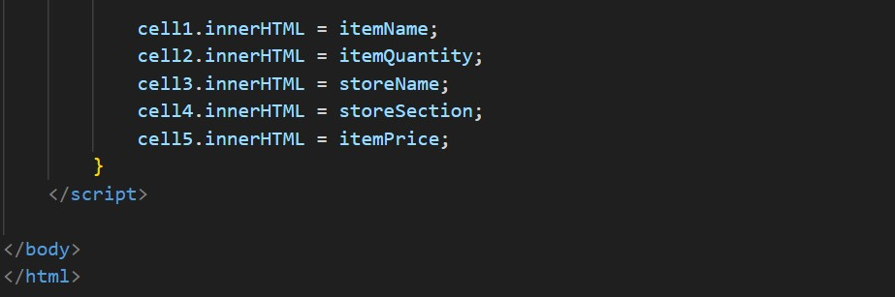

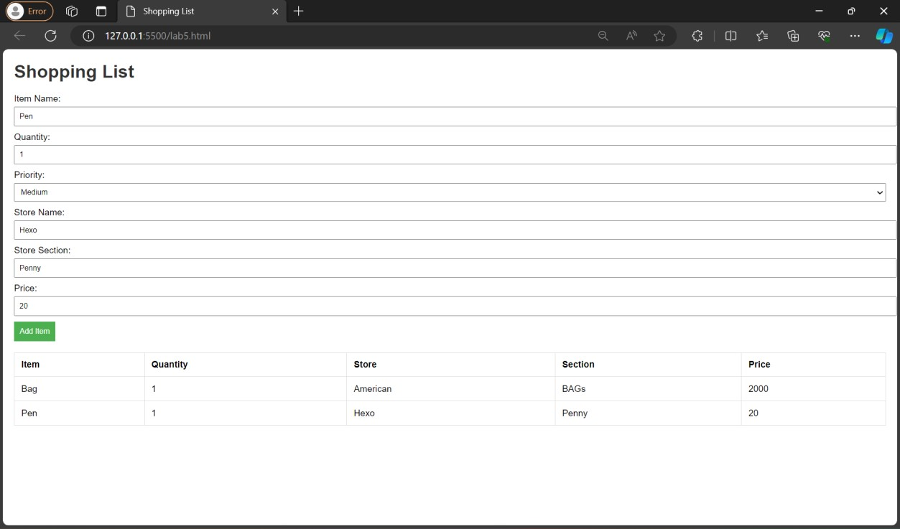

MVC Html file

<!DOCTYPE html>

<html lang="en">

<head>

<meta charset="UTF-8">

<meta name="viewport" content="width=device-width, initial-scale=1.0">

<title>Shopping List</title>

<link rel="stylesheet" href="styles.css">

</head>

<body>

<h1>Shopping List</h1>

<form id="itemForm">

<label for="itemName">Item Name:</label>

<input type="text" id="itemName" placeholder="Enter item name" required>

<label for="itemQuantity">Quantity:</label>

<input type="number" id="itemQuantity" placeholder="1" value="1" min="1" required>

<label for="itemPriority">Priority:</label>

<select id="itemPriority" required>

<option value="low">Low</option>

<option value="medium">Medium</option>

<option value="high">High</option>

|  |
| --- |
| </select>    <label for="storeName">Store Name:</label>  <input type="text" id="storeName" placeholder="Enter store name" required>    <label for="storeSection">Store Section:</label>  <input type="text" id="storeSection" placeholder="Enter store section" required>    <label for="itemPrice">Price:</label>  <input type="number" id="itemPrice" placeholder="Enter price" min="0" step="0.01" required>    <button type="button" onclick="addItem()">Add Item</button>  </form>    <table id="itemList">  <thead>  <tr>  <th>Item</th>  <th>Quantity</th>  <th>Store</th>  <th>Section</th>  <th>Price</th>  </tr>  </thead>  <tbody id="orderSummary">  Summary of your order is displayed here  </tbody>  </table>    <script src="model.js"></script>  <script src="view.js"></script>  <script src="controller.js"></script>  </body>  </html> Style.css body { font-family: 'Segoe UI', Tahoma, Geneva, Verdana, sans-serif; margin: 20px;  background: linear-gradient(135deg, #f4f4f4, #d9e9ff); } h1 { color: #da5411; text-align: center; margin-bottom: 20px; |

|  |
| --- |
| } form { margin-bottom: 20px; background: linear-gradient(180deg, #ffffff, #f0f0f0); padding: 30px; border-radius: 16px; box-shadow: 0 0 20px rgba(0, 0, 0, 0.1);  } label { display: block; margin-bottom: 16px; color: #555;  } input, select { margin-bottom: 20px; padding: 16px; width: 100%; box-sizing: border-box; border: 1px solid #ccc; border-radius: 10px; font-size: 16px; outline: none;  } button { padding: 14px; background: linear-gradient(135deg, #4CAF50, #45a049); color: white; border: none; border-radius: 10px; cursor: pointer; font-size: 16px; transition: background 0.3s ease; outline: none;  }  button:hover {  background: linear-gradient(135deg, #45a049, #4CAF50); } table { width: 100%; border-collapse: collapse; margin-top: 20px; |
| background: linear-gradient(180deg, #ffffff, #f0f0f0); box-shadow: 0 0 20px rgba(0, 0, 0, 0.1); border-radius: 16px; overflow: hidden;  } th, td { border: 1px solid #ddd; padding: 20px; text-align: left;  }    #orderSummary { background: linear-gradient(180deg, #e6f7ff, #b3d9ff); color: #0066cc; font-weight: bold; padding: 16px; border-radius: 16px; margin-bottom: 20px; text-align: center;  } |

